**Question 1)**

**Question 2)**

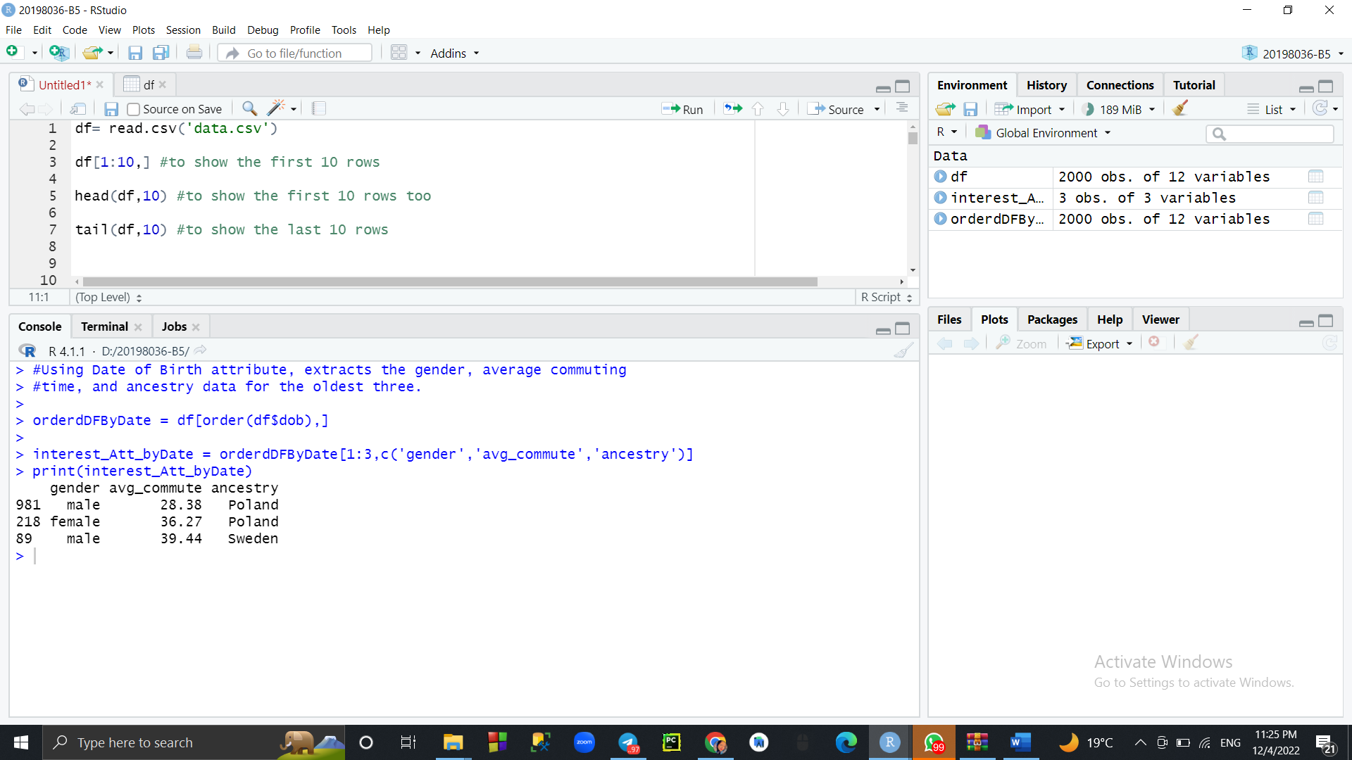

**Question 3)**

**Question 4)**

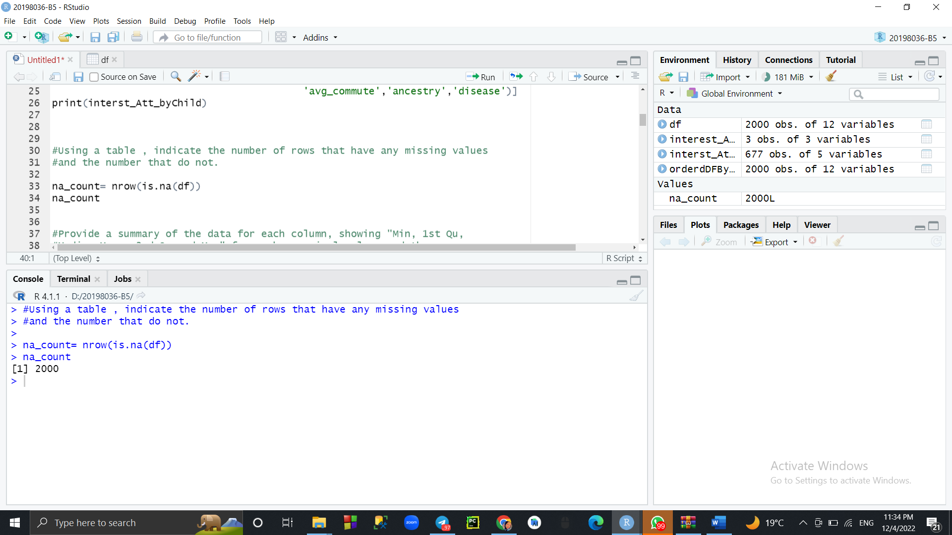

**Question 5)**

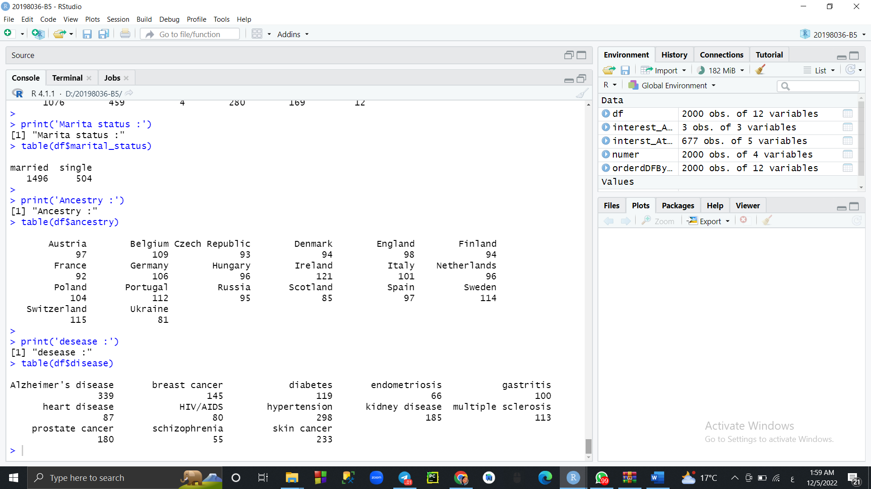

This step I don't find it okay but they told me that id and date are categorical data so I did it.

**Question 6)**

**Question 7)**

**Question 8)**

**Question 9)**

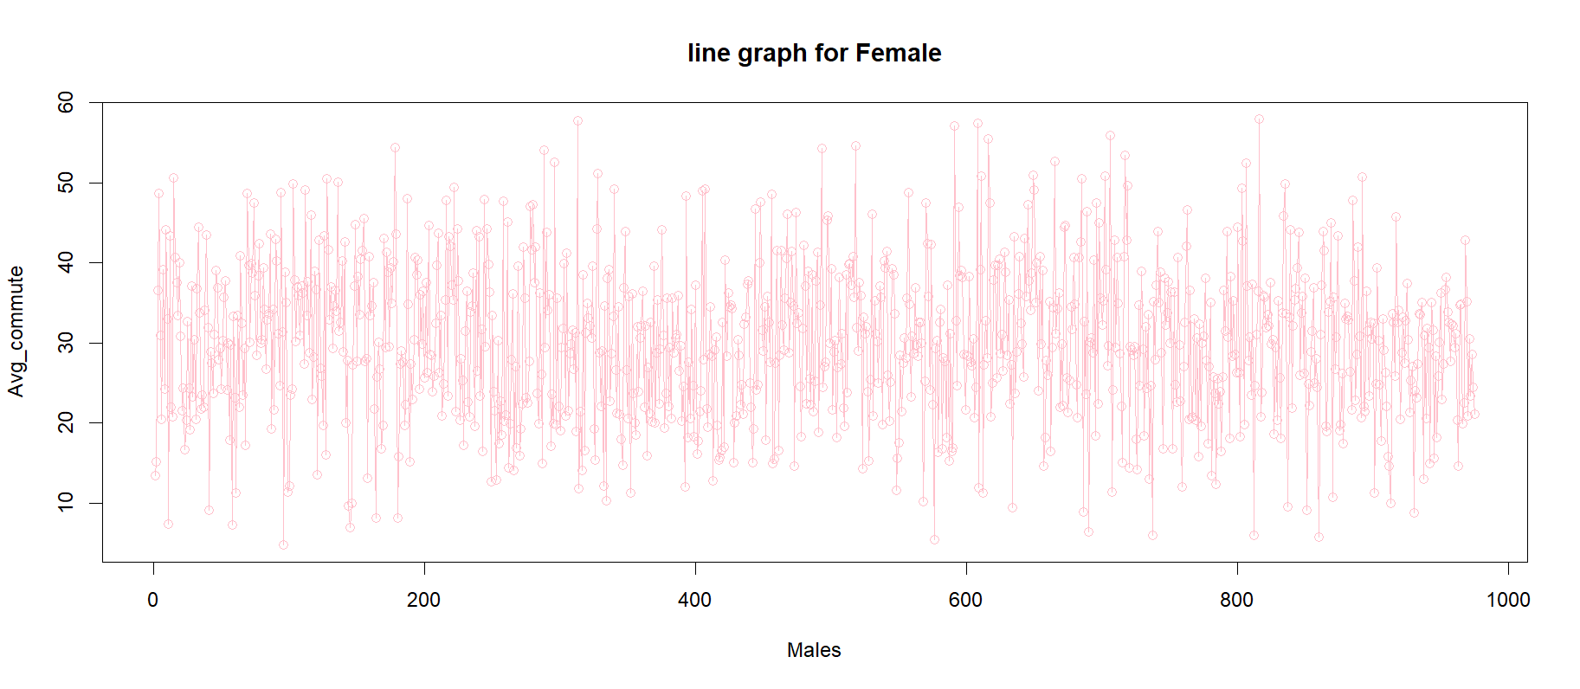

**Question 10)**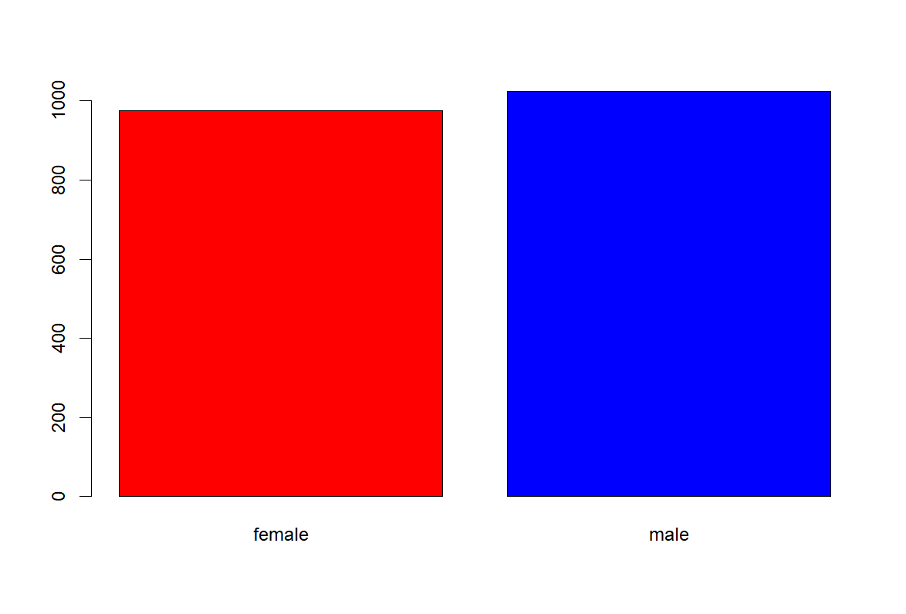

**Question 11)**

**Question 12)**

**Question 13)**

**Question 14)**

Name: Rofida Gamal Muhammed

Id: 20198036

Group : B5